

Department of Computing and Information Sciences
Semester II 2025-2026
CSDS4104-Applied Machine Learning

Medical Insurance Cost Prediction

Date: 07-05-2026
Abstract
Medical insurance costs depend on factors such as age, BMI, smoking status, number of children, gender, and region. This project develops and compares linear regression and decision tree regression models to predict insurance charges using a dataset from Kaggle and contains 1,338 records. Data preprocessing included handling missing values, encoding categorical variables, and splitting the data into training and testing sets. Model performance was evaluated using r² score, mean squared error (MSE), and root mean squared error (RMSE). Grid search with cross-validation was used to optimize the decision tree model. Results show that the decision tree regression model performs better than linear regression in capturing non-linear relationships and improving prediction accuracy. The final models were deployed using a Gradio interface for real-time insurance cost prediction.

Contents
1. Introduction 4
2. Data collection and preprocessing 4
3. Methodology 4
4. Model evaluation 4
5. Analysis and conclusion 5
6. Deployment 5
References 6

Introduction
Medical insurance costs depend on factors such as age, BMI, smoking status, number of children, gender, and region. Predicting these costs is important for helping insurance companies set fair premiums and for individuals to understand how personal and lifestyle factors influence their expenses. Many studies have applied machine learning models to predict insurance costs using the Kaggle medical insurance dataset. However, most research focuses on complex or ensemble models to improve accuracy, with less attention given to evaluating simpler and interpretable models like Decision Tree Regression. This creates a gap in understanding whether simpler models can provide competitive performance while maintaining interpretability.
Previous research has explored various machine learning approaches for this dataset. Linear Regression has been widely used as a baseline model (Cao, 2023). Comparative studies show that advanced models such as Gradient Boosting and Support Vector Machines often achieve higher accuracy (Cenita et al., 2023; Narayana et al., 2023). Other works applied Random Forest, XGBoost, and ensemble techniques, demonstrating strong predictive performance but increased complexity (Orji & Ukwandu, 2023; Hassan et al., 2023). Gradient Boosting models have also been shown to outperform traditional methods in capturing nonlinear relationships (Informatica, 2024). Additionally, several studies emphasize that the dataset from Kaggle is commonly used for evaluating regression models in healthcare cost prediction (Kaggle, 2023).
Therefore, this project aims to compare Linear Regression and Decision Tree Regression to determine which model better predicts insurance charges. Model performance will be evaluated using R², MSE, and RMSE.

Data collection and preprocessing
The dataset used in this study was obtained from Kaggle and contains 1,338 records of medical insurance data for individuals in the United States. The features include age, gender, BMI, number of children, smoking status, and region, with insurance charges as the target variable. Data preprocessing involved encoding categorical variables, checking for missing values, and preparing the dataset for modelling. The data was then split into training and testing sets to evaluate the performance of both Linear Regression and Decision Tree Regression models.

Methodology
In this study, a supervised machine learning approach was used to predict medical insurance charges. First, the dataset was cleaned by handling missing values using median and mode imputation depending on the data type. Duplicate records were removed to ensure data quality. Next, categorical variables such as sex, smoker, and region were encoded using binary encoding and one-hot encoding. This step converted non-numeric data into a numerical format suitable for machine learning models. The dataset was then split into training (80%) and testing (20%) sets to evaluate model generalization. Two regression models were implemented: Linear Regression (baseline model) and Decision Tree Regression (non-linear model). Feature scaling was applied using the Standard Scaler to improve model stability, especially for Linear Regression. Finally, feature importance was analyzed using an ANOVA F-test to identify the most influential variables affecting insurance charges.

Model evaluation
Model performance was evaluated using R² Score, which measures how well the model explains variance in the target variable, and Mean Squared Error (MSE): measures average squared prediction error. For visualization, a scatter plot comparing actual vs predicted values shows how closely predictions match real insurance charges. Linear Regression showed a more linear pattern but struggled with non-linear relationships. Decision Tree captured complex patterns better, improving accuracy in some cases.

Analysis and conclusion
The results show that both models can predict insurance charges, but their performance differs. Linear Regression performs well when relationships between variables are linear, whereas Decision Tree Regression is better at capturing non-linear interactions among features such as BMI, smoking status, and age. The Decision Tree Regression model outperformed Linear Regression, achieving a higher R² score and lower MSE. This indicates that the Decision Tree model is better at capturing non-linear relationships between features and insurance charges. However, Decision Trees may suffer from overfitting if not properly tuned. The use of Grid Search CV helped optimize hyperparameters such as max depth and min samples leaf, improving generalization. Overall, Decision Tree Regression is more effective for this dataset, but Linear Regression remains useful as a simple and interpretable baseline model.
The Decision Tree Regression model achieved an R² score of 0.9004, indicating strong predictive performance in explaining variations in medical insurance charges. When compared with prior studies, it significantly outperforms baseline Linear Regression models reported by (Cao, 2023), which typically achieve R² values around 0.70–0.75. It also performs slightly better than Support Vector Machine models reported in (Cenita et al., 2023; Narayana et al., 2023) , which generally range between 0.80 and 0.85. However, ensemble-based methods such as Random Forest (Orji & Ukwandu, 2023; Hassan et al., 2023) and Gradient Boosting (Informatica, 2024) still achieve higher predictive accuracy, often exceeding 0.90–0.95 due to their ability to reduce variance and improve generalization. Despite this, the Decision Tree model remains valuable due to its interpretability and relatively strong performance, making it a suitable trade-off between simplicity and accuracy.

Deployment
The trained model can be deployed in a real-world healthcare or insurance system to estimate medical charges based on user input. We used Gradio to build a simple interactive interface that collects user inputs for all relevant features and predicts insurance charges using both linear regression and decision-tree regression models. The implementation was developed with guidance from the official Gradio documentation (Gradio, 2023), which helped structure the interface class and efficiently handle user input-output flow.

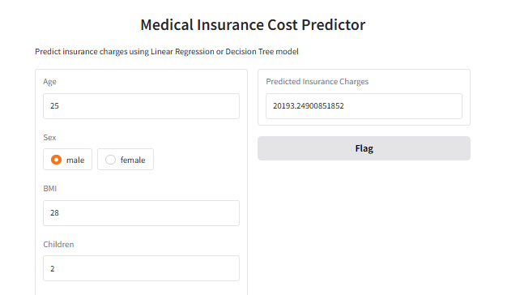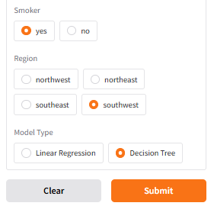

References
Cao, C. (2023). Prediction of medical insurance cost through linear regression model. Retrieved on May 4, 2026 from https://drpress.org/ojs/index.php/HSET/article/view/10287
Cenita, J. A. S., Asuncion, P. R. F., & Victoriano, J. M. (2023). Performance evaluation of regression models in predicting the cost of medical insurance. Retrieved on May 4, 2026 from https://arxiv.org/abs/2304.12605
Orji, U., & Ukwandu, E. (2023). Machine learning for an explainable cost prediction of medical insurance. Retrieved on May 4, 2026 from https://www.sciencedirect.com/science/article/pii/S2666827023000695
Informatica. (2024). Medical insurance cost prediction using gradient boosting regression. Retrieved on May 4, 2026 from https://www.informatica.si/index.php/informatica/article/view/8100
Hassan, C. A., Iqbal, J., Hussain, S., et al. (2023). A computational intelligence approach for predicting medical insurance cost. Retrieved on May 4, 2026 from https://ideas.repec.org/a/hin/jnlmpe/1162553.html
Narayana, K. L., Yogesh, P., & Kowshik, P. (2023). Medical insurance premium prediction using regression models. Retrieved on May 4, 2026 from https://openrgate.org/viewfulldetails.php?id=19225
Kaggle. (2023). Medical insurance cost prediction dataset. Retrieved on April 18, 2026 from https://www.kaggle.com/datasets/hetmengar/medical-insurance-cost-prediction
Gradio. (2023). The Interface class. Retrieved April 18, 2026, from https://www.gradio.app/guides/the-interface-class

